NAME:T.mohana rao
H.no:2303A52446
ASSIGNMENT-9.3
TASK-1: Auto-Generating Function Documentation in a Shared
Codebase
PROMPT:
Insert Google-style docstrings for every top-level function in this Python file that lacks one. Each docstring must include: a one-line summary, Args (with types), Returns (with type), Raises (if applicable), and at least one short Example. Do not change code behavior—only add docstrings. Return the full updated file.
Completed version with Google-style docstrings: 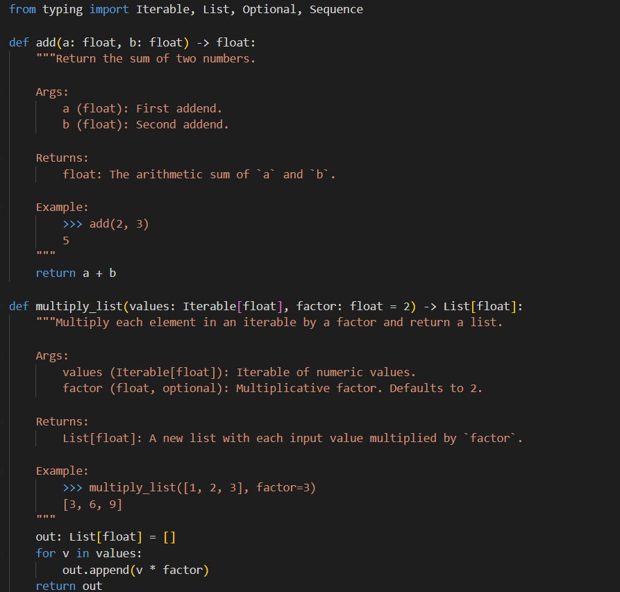

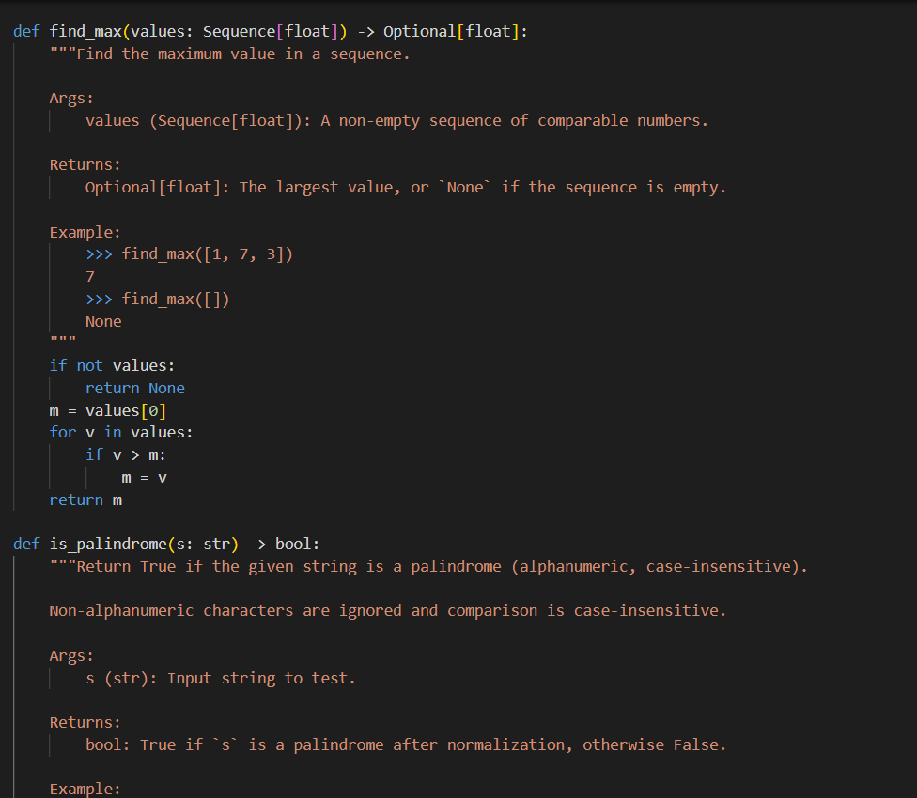
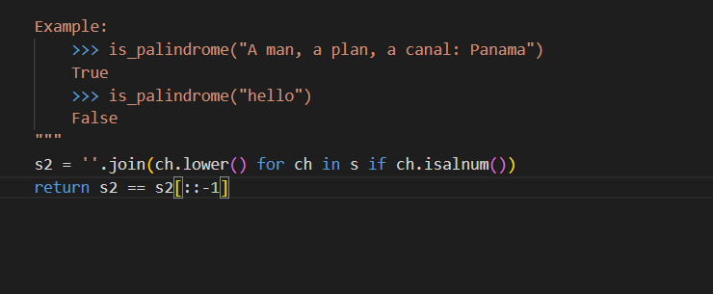
JUSTIFICATION:
- Speeds onboarding: new team members understand function purpose and usage immediately.
- Makes contracts explicit: documents parameter types, return values, and error conditions so callers know expectations.
- Improves developer UX: IDEs and editor tooltips show readable summaries and examples, reducing context switches.
- Enables automated docs and tooling: consistent docstrings are parsed by Sphinx, linters, and type-checking tools.
- Increases maintainability and review quality: clear docs reduce misunderstandings during refactors and code reviews.
- Low risk, high ROI: only adds documentation (no behavior changes) while delivering outsized long-term productivity gains.

TASK-2:Enhancing Readability Through AI-Generated Inline comments
Prompt :
```text
Insert concise inline comments into this Python file. Only add comments for complex or non-obvious logic (algorithms, loop invariants, pivot/partition choices, performance/space trade-offs). Avoid commenting trivial syntax or restating the code. Explain why the code works or why choices were made, not how Python syntax works. Preserve behavior and formatting; return the full updated file.
```

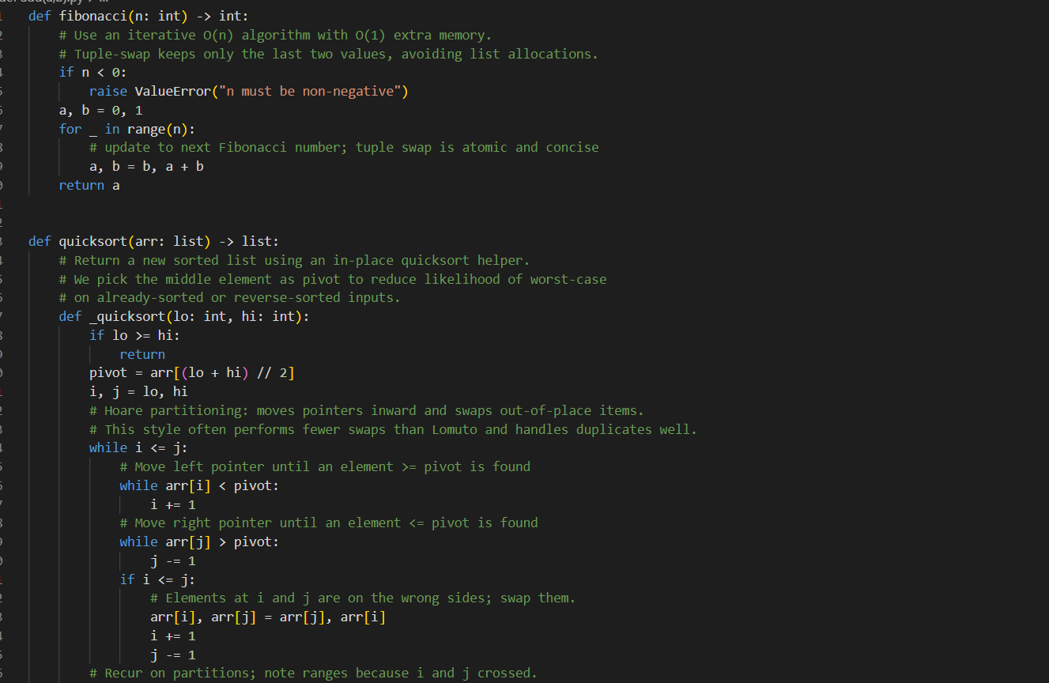
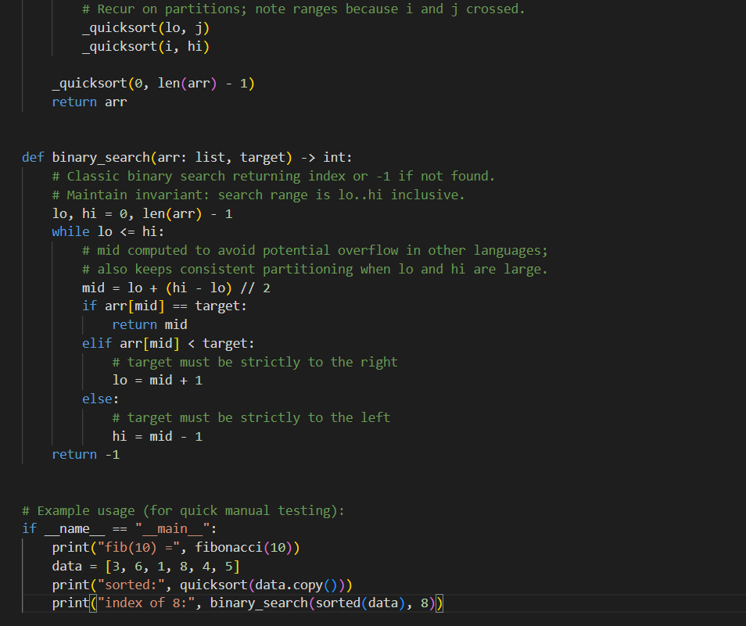
JUSTIFICATION:
- Targets only non-obvious parts (algorithms, invariants, trade-offs) so comments help comprehension without clutter.
- "Why-focused" comments guide future maintainers on design decisions and edge cases, speeding debugging and safe refactors.
- Preserving code and minimal commenting keeps risk low while delivering clear, actionable context for readers and IDE tooltips.
TASK-3: Generating Module-Level Documentation for a Python package
Prompt: Add a module-level docstring to the top of this Python file. Describe the module's purpose, required dependencies, brief descriptions of key functions/classes, and include a short usage example. Keep tone professional and the docstring multi-line.
Code:
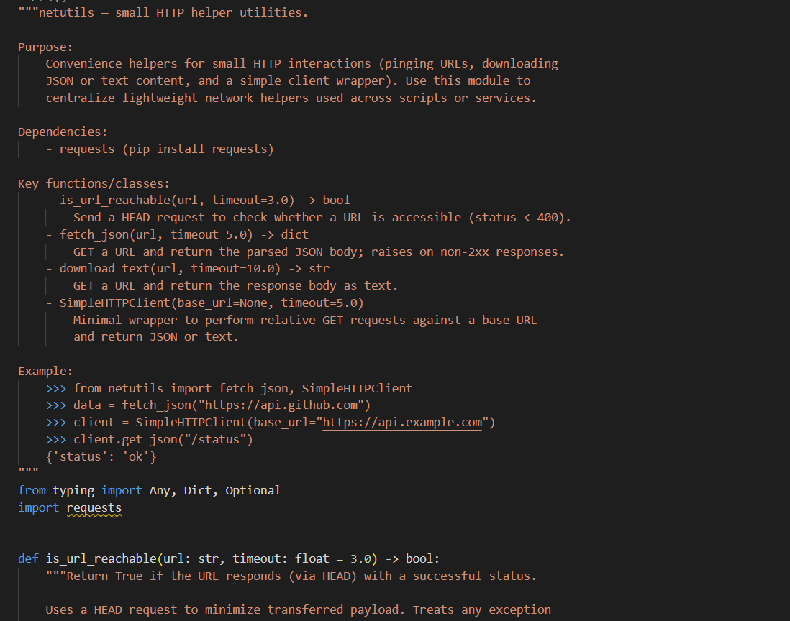
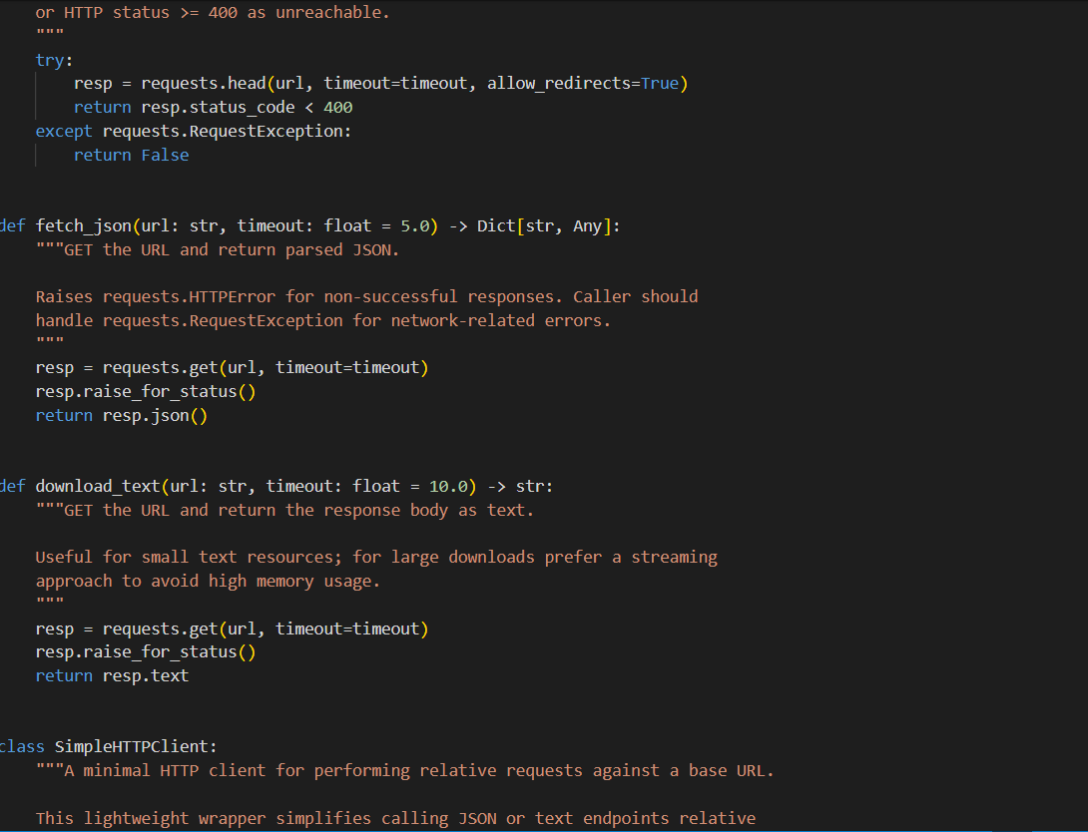
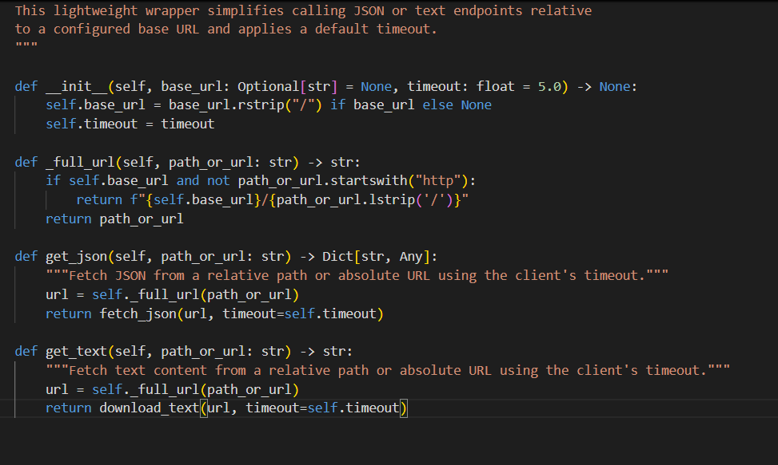
JUSTIFICATION:
- A module-level docstring gives an immediate, high-level overview (purpose, deps, key API) to anyone opening the file, speeding onboarding and review.
- Listing dependencies and short examples reduces friction for reuse and testing.
- Including brief function/class summaries helps maintainers and tooling (IDE tooltips, Sphinx) without reading the entire implementation.
TASK-4: Converting Developer Comments into Structured Docstrings
PROMPT:
Convert long inline comments inside functions into Google-style docstrings placed immediately after each def. Move explanatory comments (purpose, algorithm, invariants, edge cases) into the docstring and remove redundant inline comments from the body. Preserve behavior, types, and wording where possible. Return the full updated file.
CODE:
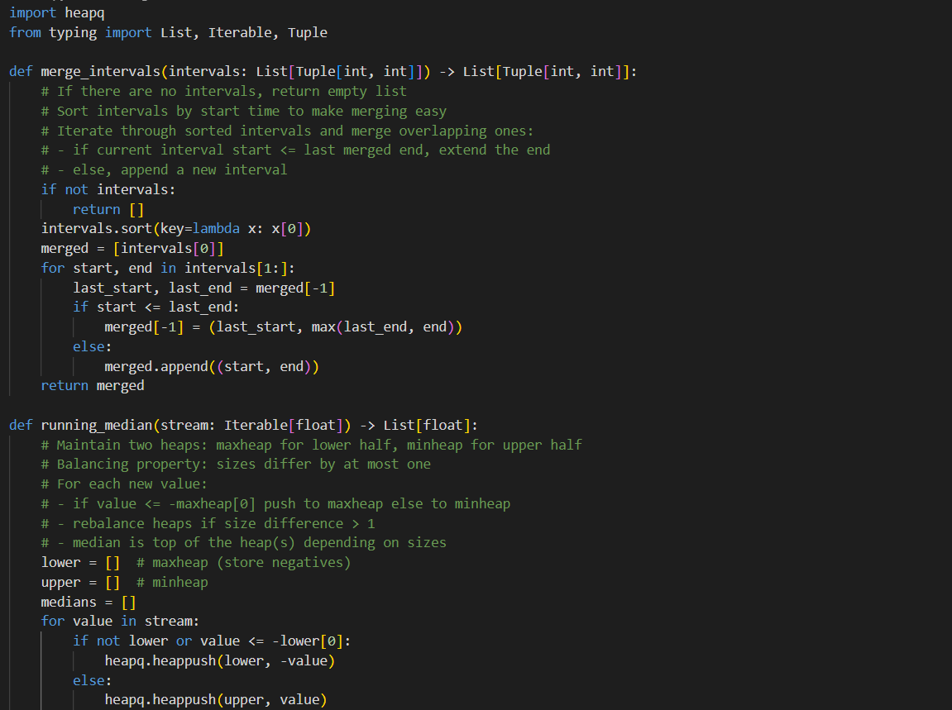
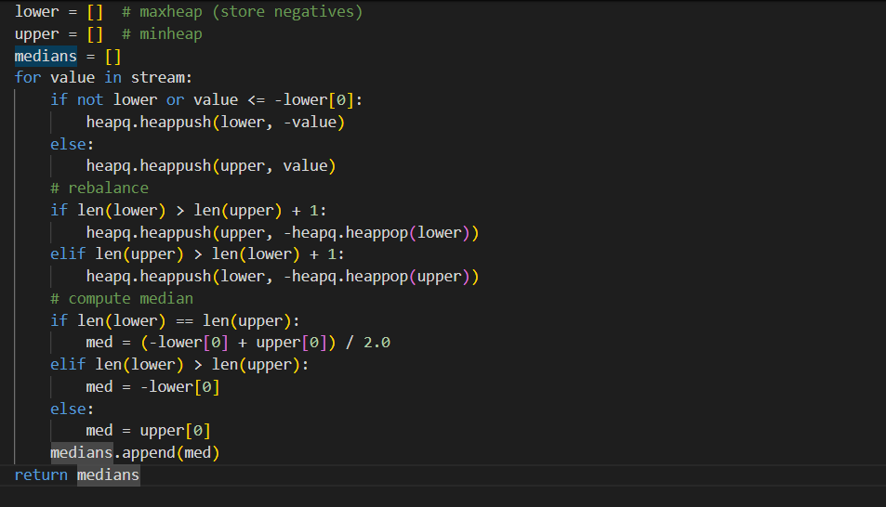
JUSTIFICATION:
- Moving explanatory comments into docstrings standardizes documentation and surfaces intent to tools/IDEs.
- Removing redundant inline comments declutters function bodies and focuses comments on non-obvious points captured in docstrings.
- Google-style docstrings provide a consistent, machine-parseable format for API docs, type hints, and onboarding.
TASK-5: Building a Mini Automatic Documentation Generator
PROMPT:
"Generate a Python utility that scans a .py file, finds functions and classes, and inserts Google-style placeholder docstrings automatically."
CODE:
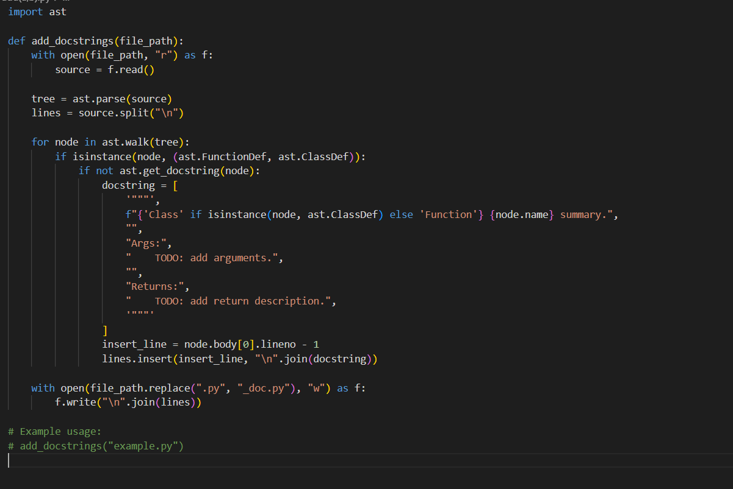
JUSTIFICATION:
This utility leverages Python’s ast module to parse the file structure safely, ensuring functions and classes are detected without executing code. It checks for missing docstrings and inserts Google-style placeholders, giving developers a quick starting point for documentation while maintaining consistency.

